**DOWNSAMPLING**:Upsampling is the process of inserting zero-valued samples between original samples to increase the sampling rate.

**UPSAMPLING:**To make a digital audio signal smaller by lowering its sampling rate or sample size (bits per sample). Downsampling is done to decrease the bit rate when transmitting over a limited bandwidth or to convert to a more limited audio format.

**INTERPOLATION(RECONSTRUCTION)**:In the domain of digital signal processing, the term interpolation refers to **the process of converting a sampled digital signal (such as a sampled audio signal) to that of a higher sampling rate (Upsampling) using various digital filtering techniques** (for example, convolution with a frequency-limited impulse signal).

**DECIMATION:**Decimation is **the process of reducing the sampling frequency of a signal to a lower sampling frequency that differs from the original frequency by an integer value**. Decimation also is known as down-sampling.

**RESAMPLING:**Resampling is used to either increase the sample rate (make the image larger) or decrease it (make the image smaller).Resampling is **the process of changing the sampling rate of an existing signal**. A new signal should keep all information contained in the original signal.

**ALIASING**:Aliasing is when a continuous-time sinusoid appears as a discrete-time sinusoid with multiple frequencies.

There are two important points to take away about downsampling's effects in the frequency domain:

1. The downsampled signal's frequency spectrum will have its magnitude lowered by the downsampling factor *D*, and will repeat every 2*π*
2. Downsampling can cause aliasing. To prevent this, we need to lowpass filter BEFORE the downsampling causes any aliasing.
3. subplot( m , n , p ) **divides the current figure into an m -by- n grid and creates axes in the position specified by p** .
4. stem( X , Y ) **plots the data sequence, Y , at values specified by X** . The X and Y inputs must be vectors or matrices of the same size. Additionally, X can be a row or column vector and Y must be a matrix with length(X) rows.
5. **what is discrete Fourier transform** (**DFT**) ?

Ans:the **discrete Fourier transform** (**DFT**) converts a finite sequence of equally-spaced [samples](https://en.wikipedia.org/wiki/Sampling_(signal_processing)" \o "Sampling (signal processing)) of a [function](https://en.wikipedia.org/wiki/Function_(mathematics)" \o "Function (mathematics)) into a same-length sequence of equally-spaced samples of the [discrete-time Fourier transform](https://en.wikipedia.org/wiki/Discrete-time_Fourier_transform" \o "Discrete-time Fourier transform) (DTFT), which is a [complex-valued](https://en.wikipedia.org/wiki/Complex_number" \o "Complex number) function of frequency.

Q.What is meant by Fast Fourier transform?

ANS:A fast Fourier transform (FFT) is **an algorithm that computes the discrete Fourier transform (DFT) of a sequence, or its inverse (IDFT)**. Fourier analysis converts a signal from its original domain (often time or space) to a representation in the frequency domain and vice versa.

1. DIT (**Decimation in time**) and DIF( Decimation in frequency) algorithms are two different ways of implementing the Fast Fourier Transform (FFT) ,thus reducing the total number of computations used by the DFT algorithms and making the process faster and device-friendly.

(DIT):Decimation-In-Time algorithm is **used to calculate the DFT of an N point sequence**. The idea is to break the N point sequence into two sequences, the DFTS of which can be combined to give the DFT of the original N point sequence.

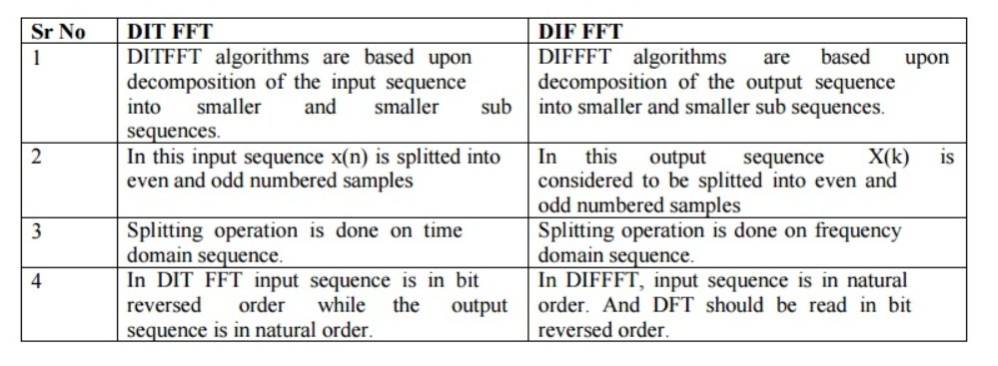

**In DITFFT, input is bit reversed while the output is in natural order, whereas in DIFFFT, input is in natural order while the output is in bit reversal order**.

*How does Sobel filter work?

The Sobel filter is used for edge detection. It works **by calculating the gradient of image intensity at each pixel within the image**. It finds the direction of the largest increase from light to dark and the rate of change in that direction.

*The **Canny edge detector** is an [edge detection](https://en.wikipedia.org/wiki/Edge_detection" \o "Edge detection) operator that uses a multi-stage [algorithm](https://en.wikipedia.org/wiki/Algorithm" \o "Algorithm) to detect a wide range of edges in images.

*The Prewitt operator is based on **convolving the image with a small, separable, and integer valued filter in horizontal and vertical directions** and is therefore relatively inexpensive in terms of computations like Sobel and Kayyali operators.

\*\*\***Image segmentation** involves **converting an image into a collection of regions of pixels that are represented by a mask or a labeled image**. By dividing an image into segments, you can process only the important segments of the image instead of processing the entire image.

***Histogram Equalization is **a computer image processing technique used to improve contrast in images** . It accomplishes this by effectively spreading out the most frequent intensity values, i.e. stretching out the intensity range of the image.

An image histogram is **a gray-scale value distribution showing the frequency of occurrence of each gray-level value**.

In digital images, grayscale means that **the value of each pixel represents only the intensity information of the light**.

